IAM & AWS CLI

AWS Solution Architect Associate

# Section 4: IAM & AWS CLI

## 14. IAM MFA Overview

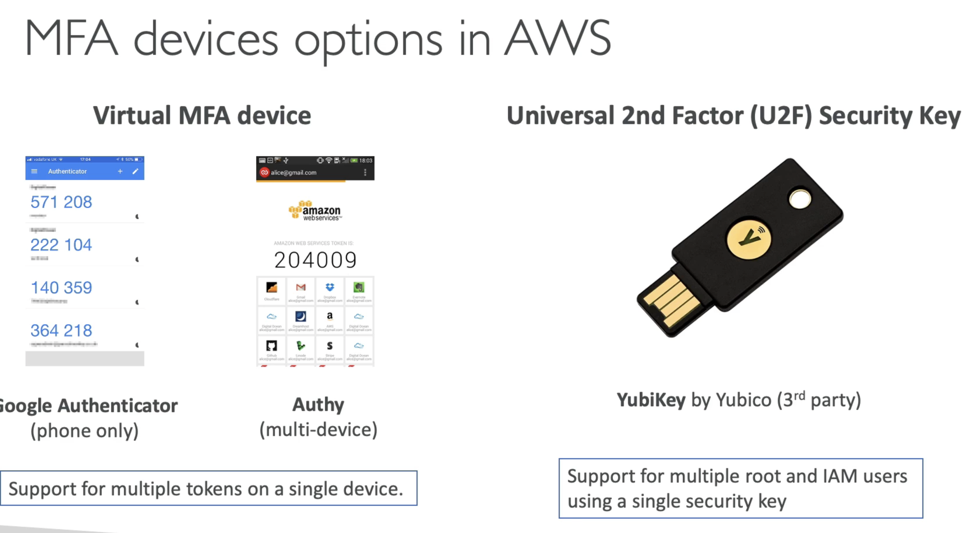

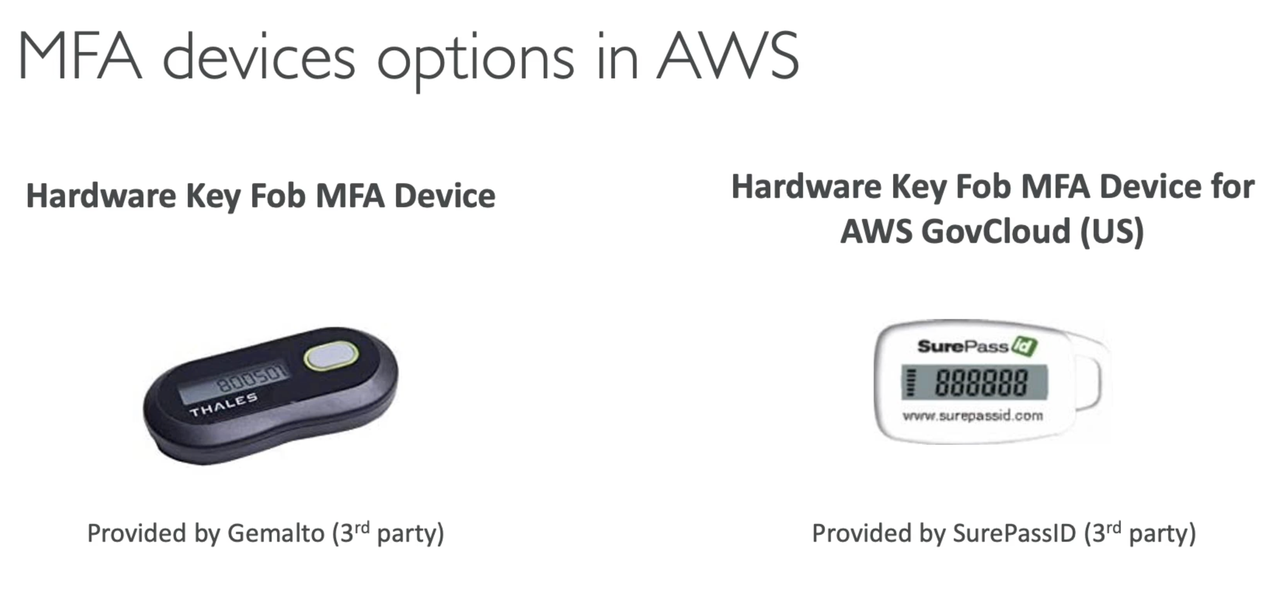

## 21. AWS CloudShell

AWS CLI on the AWS Console. So you can run AWS CLI commands from browser using CloudShell

## 24. IAM Security Tools

# Section 23: Identity Access Management (IAM) - Advanced

## 239. Security Token Service – STS

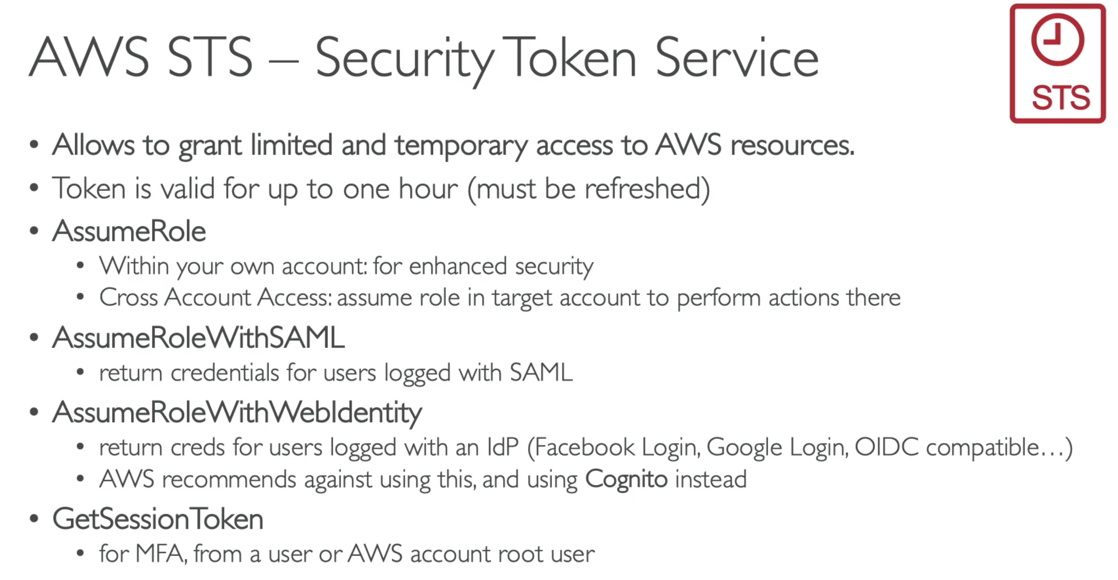

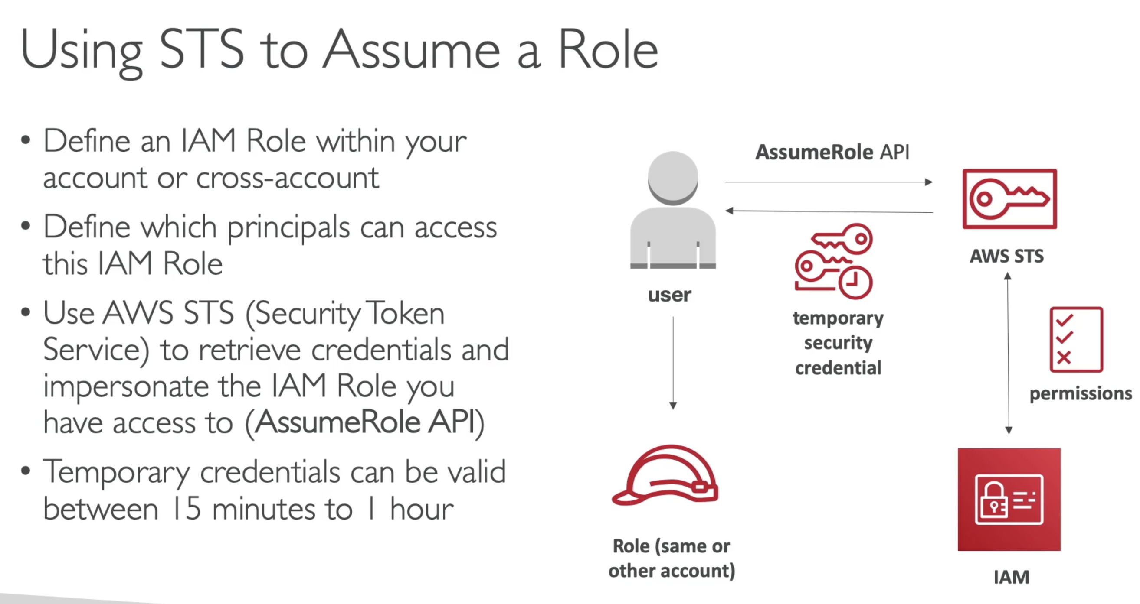

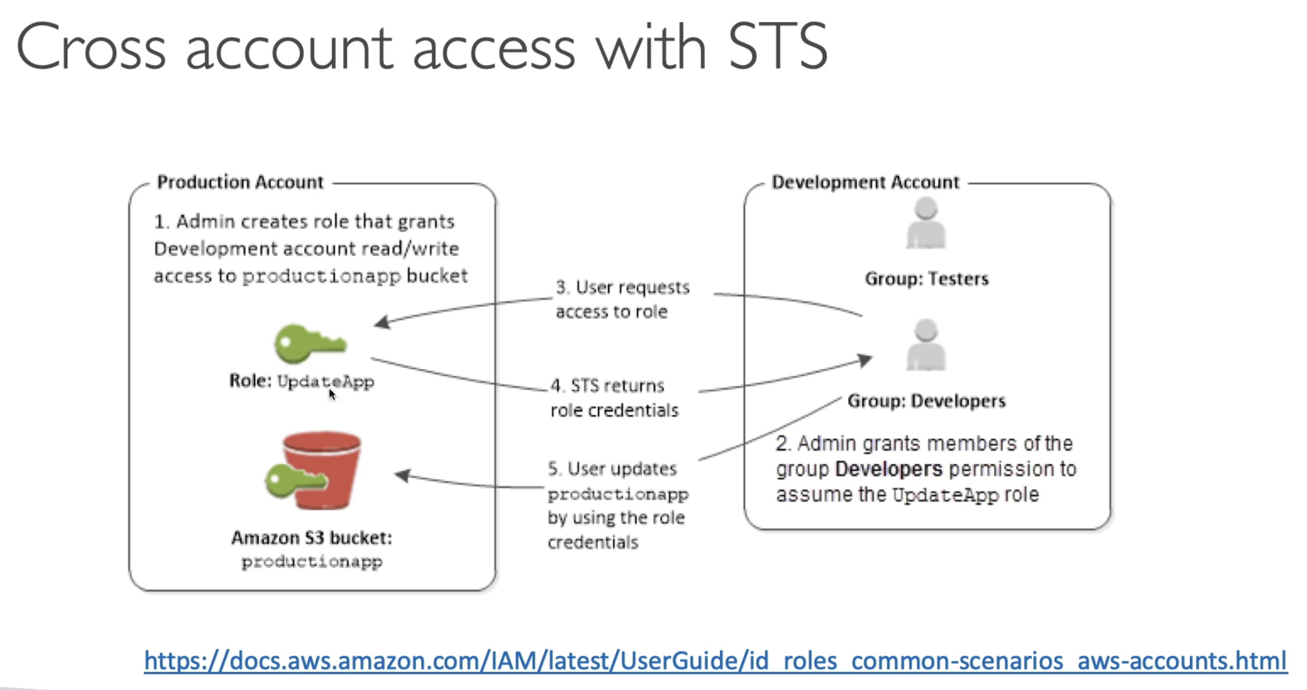

* You should never share credentials cross account.
* You create roles and make sure that your users assume that role and STS will return you the role credentials, which is temporary. So if you lose them, this is not as bad as leaking entire credentials of an account.
* IF you see in the exam – key words like **Cross-Account Access, Assuming Role 🡪** think of STS

## 240. Identity Federation and Cognito

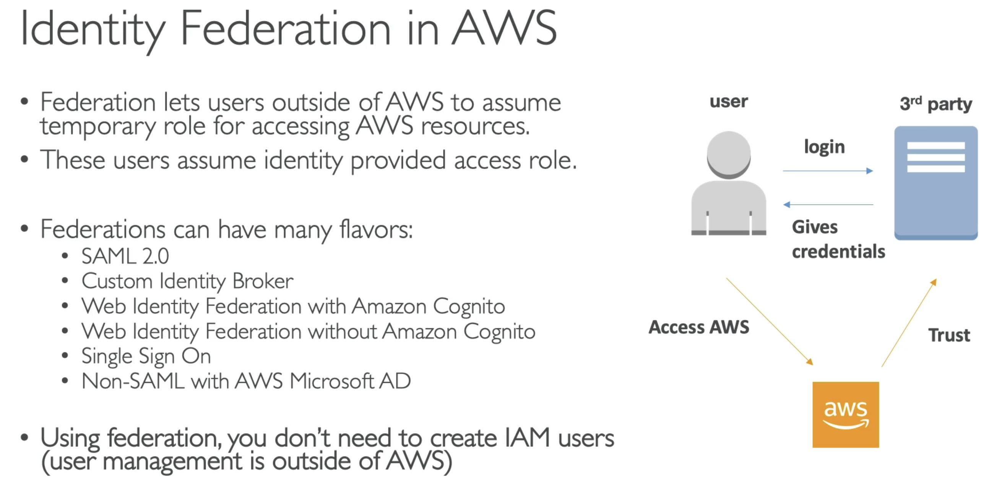

### SMAL 2.0 Federation

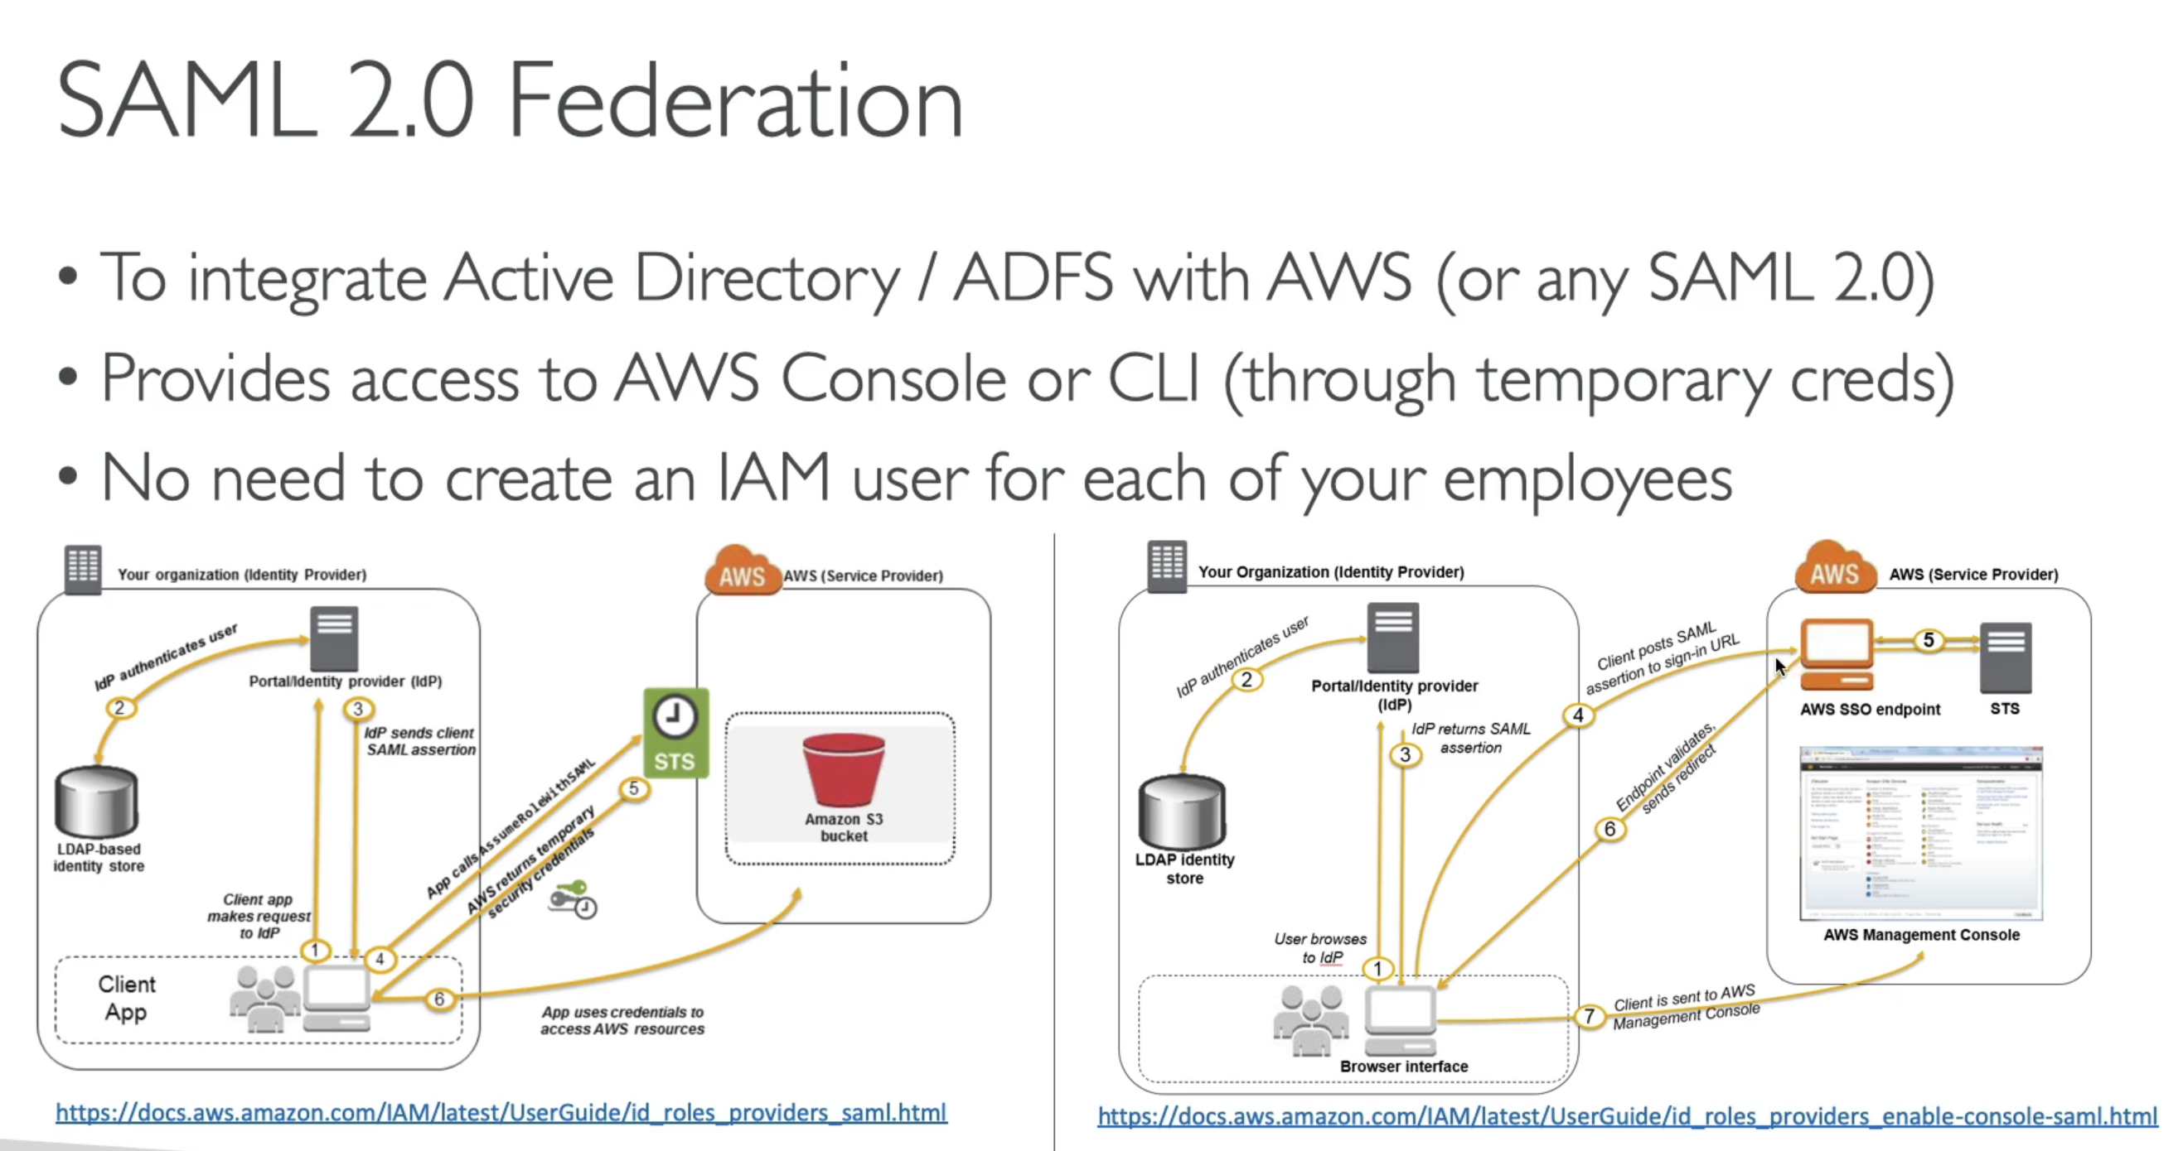

* We first authenticate user within our organisation
* Exchange SAML 2.0 assertion for some credentials within AWS using STS
* And we are able to programmatically access AWS resources or the console

### SAML 2.0 Federation – Active Directory FS

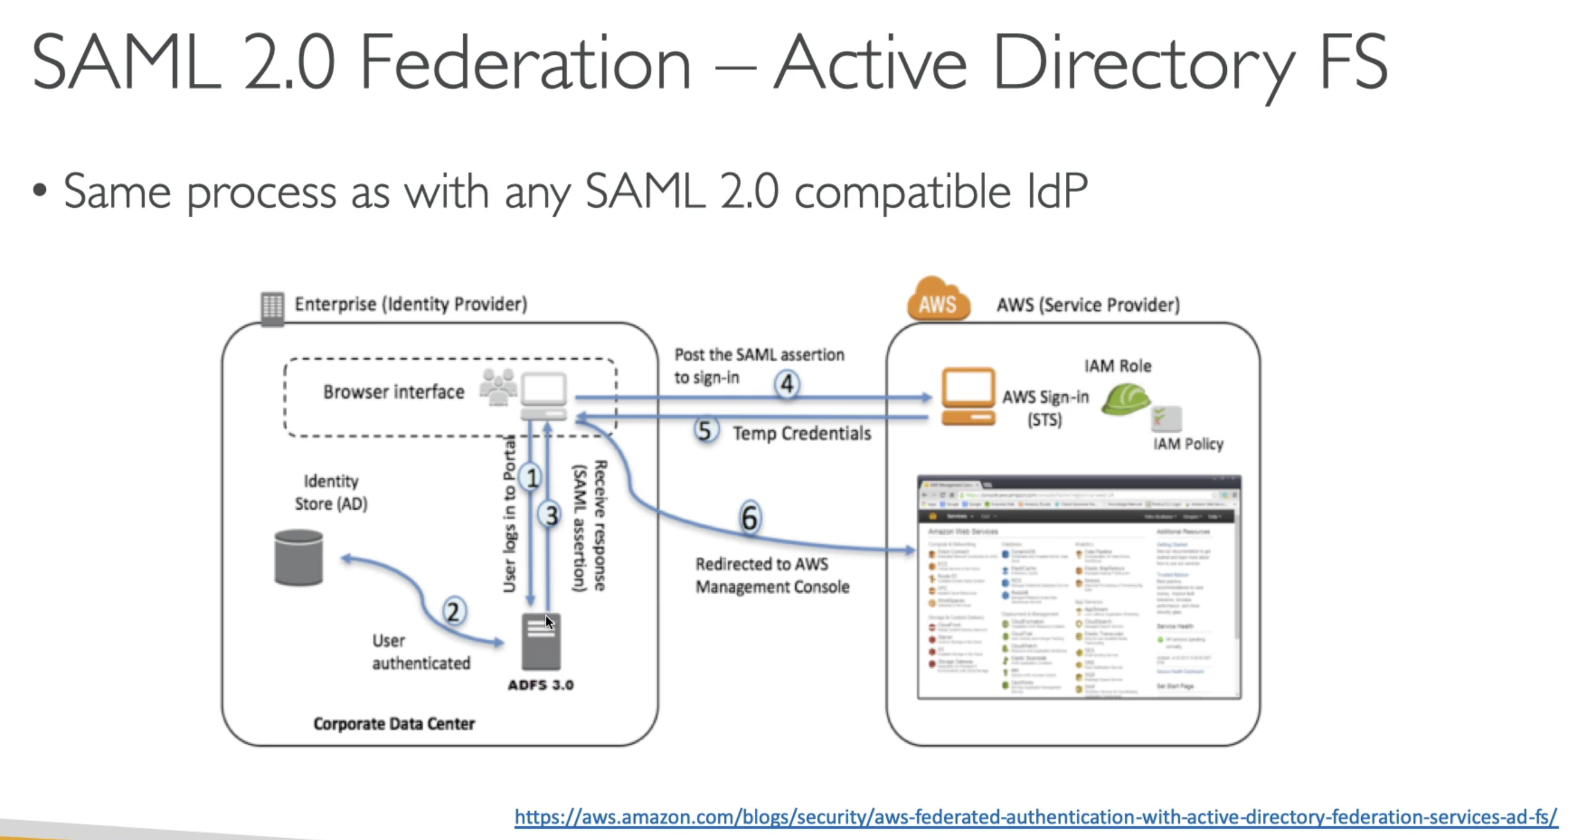

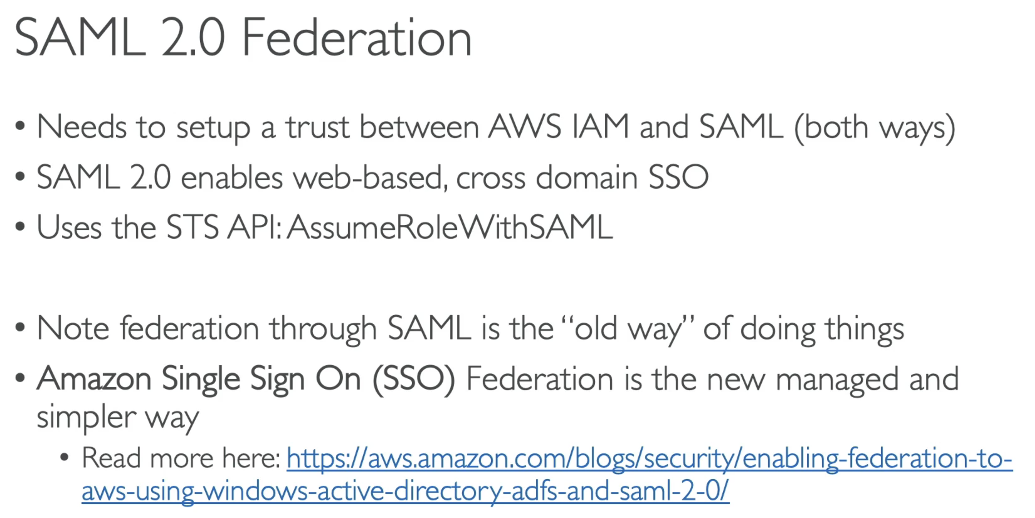

### Custom Identity Broker

What if our current on-premises store is not compatible with SAML 2.0…

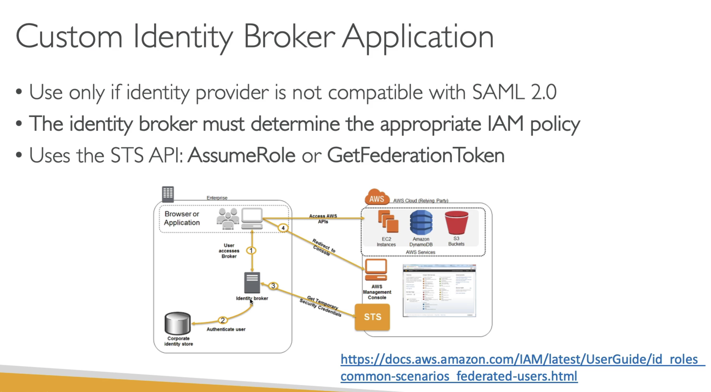

### Web Identity Federation

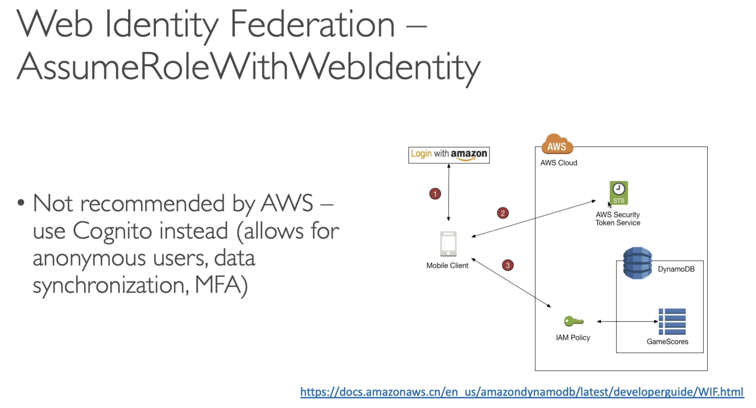

3-way process:

* We first login with our identity provider
* We exchange with STS;
  + STS will validate the login and return some AWS credentials
* We have access to AWS
  + Now the mobile client has some AWS credentials, with which it can access some IAM policy and then some AWS resource

### AWS Cognito

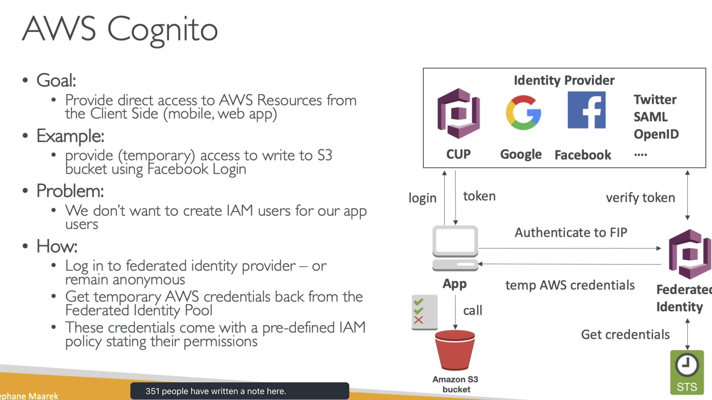

## 241. Directory Service Overview

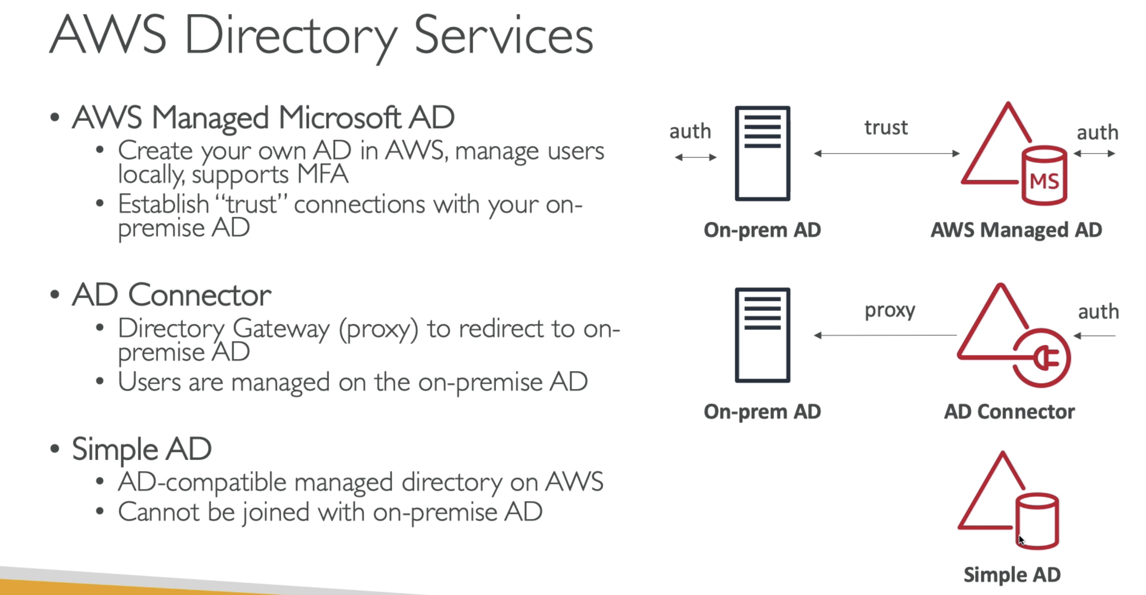

## 242. Organizations – Overview

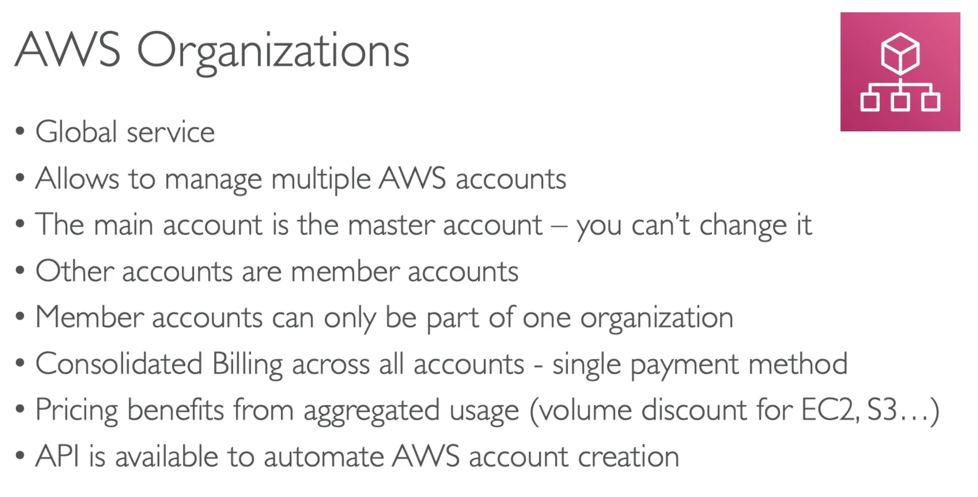

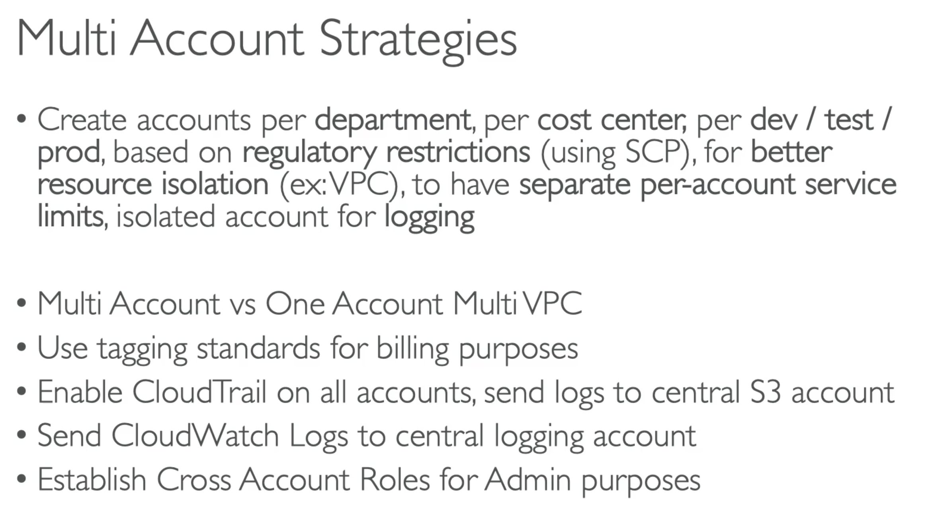

### Organizational Units

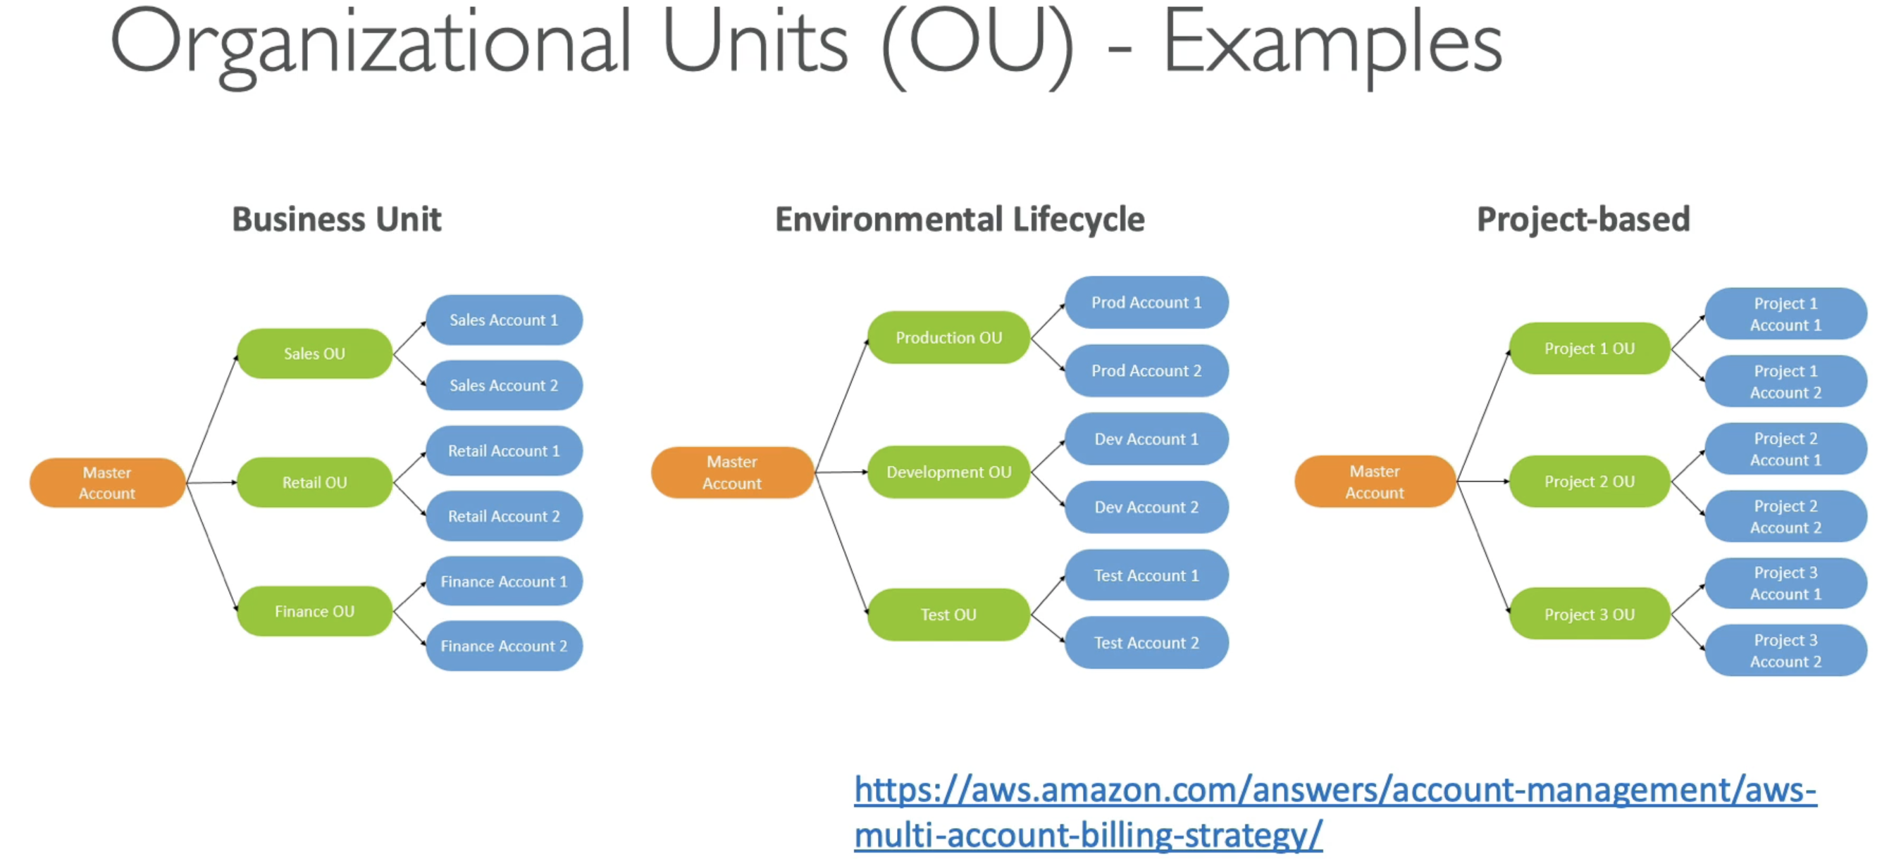

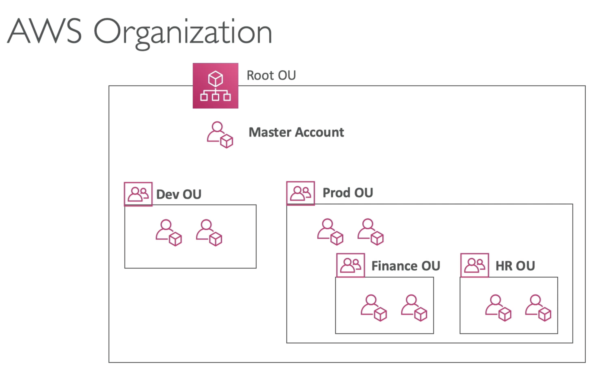

* We can create a structure of our choice with Organizations
* Add any number of accounts within it
* Accounts will inherit some rules and SCP

### Service Control Policy – SCP

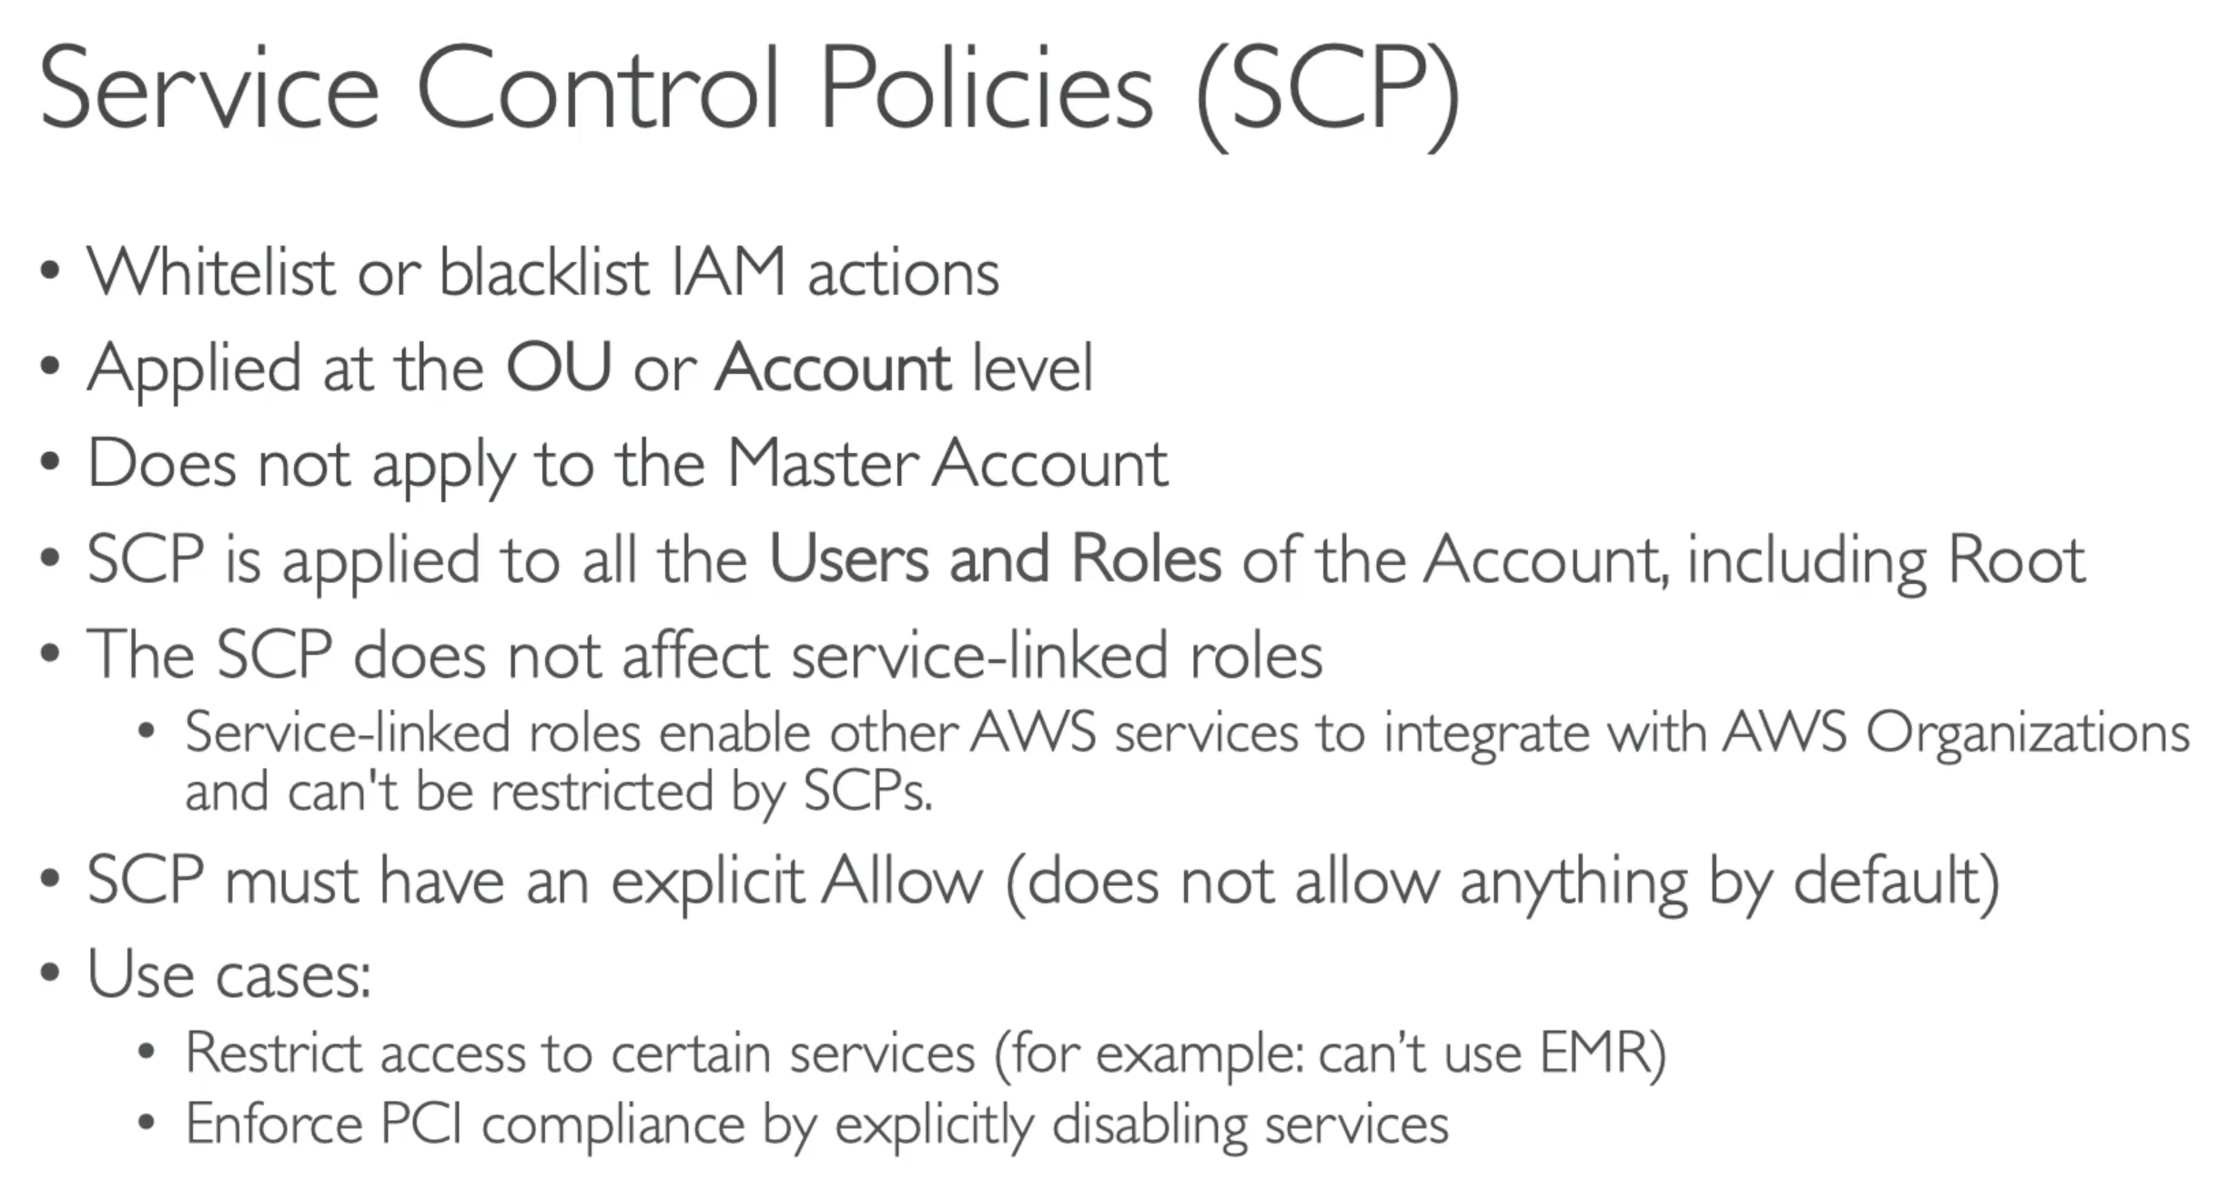

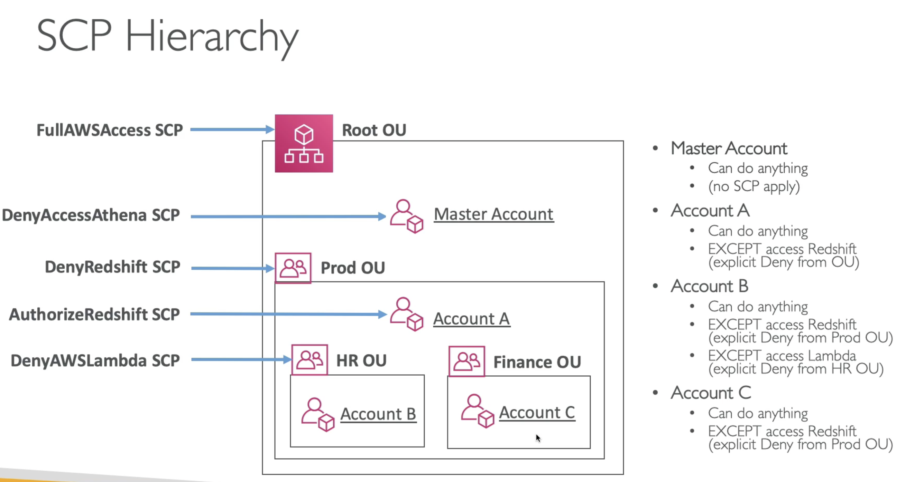

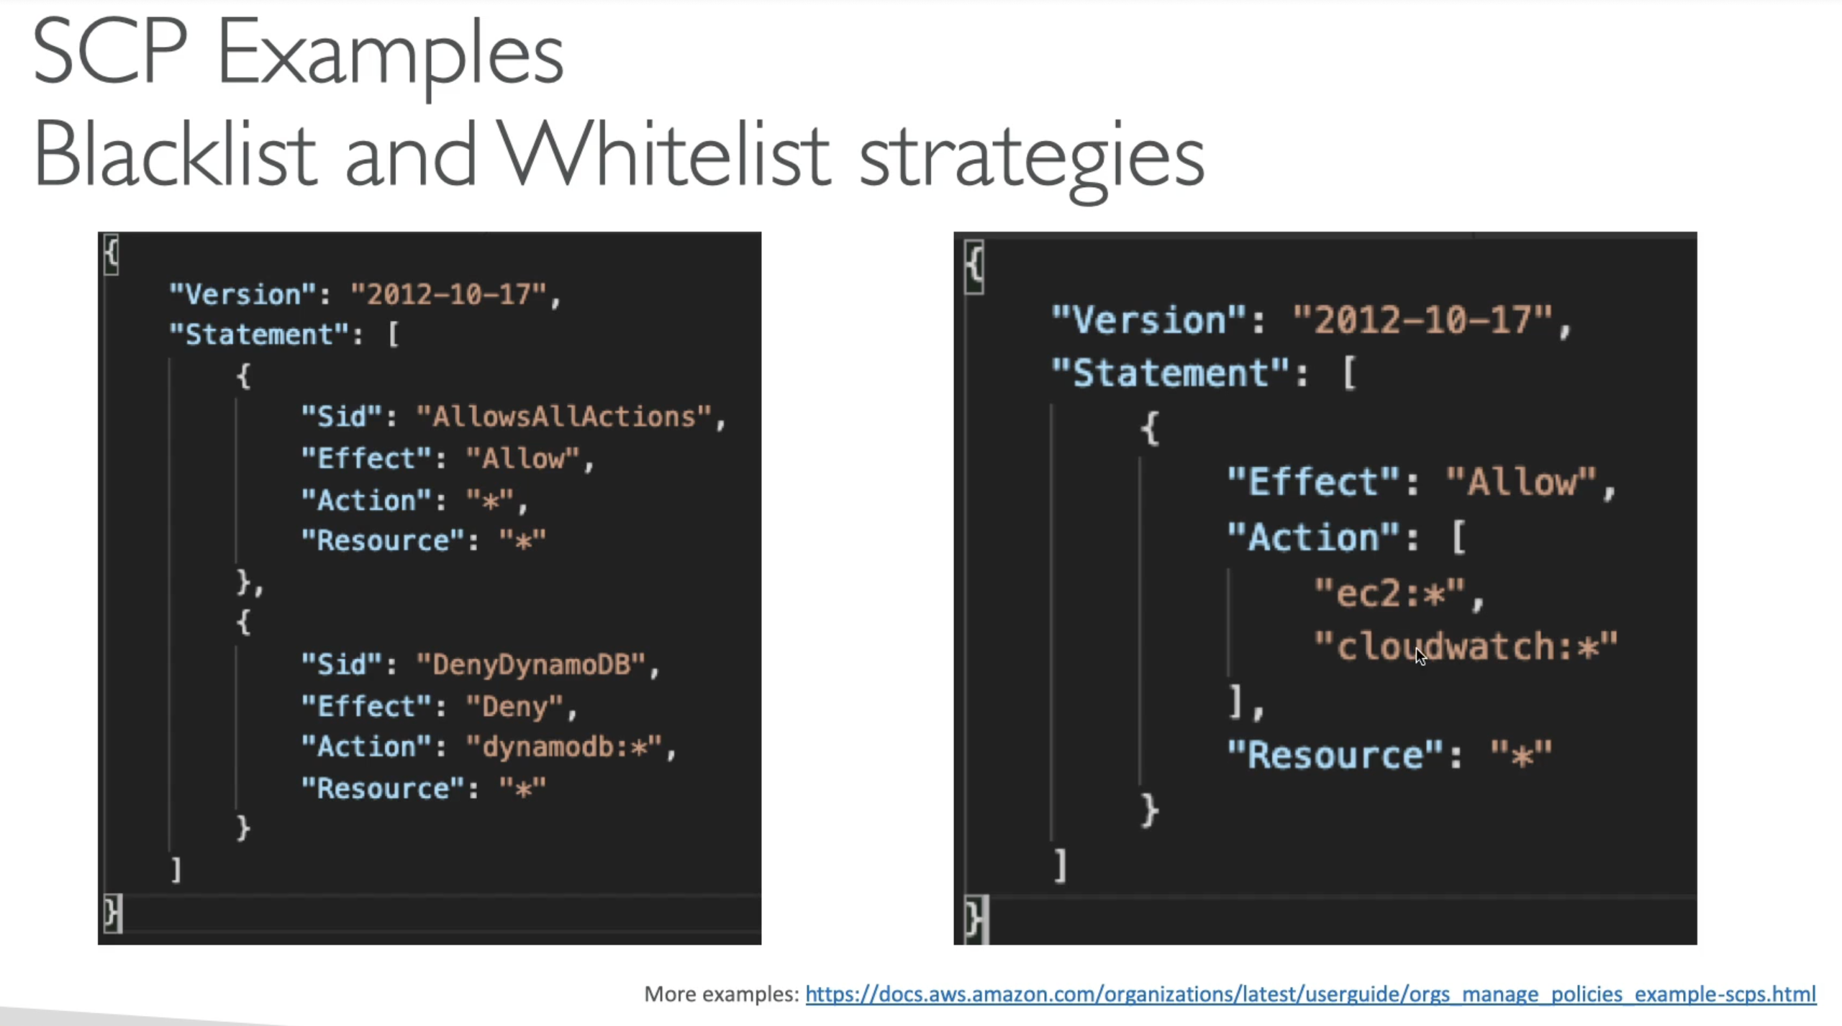

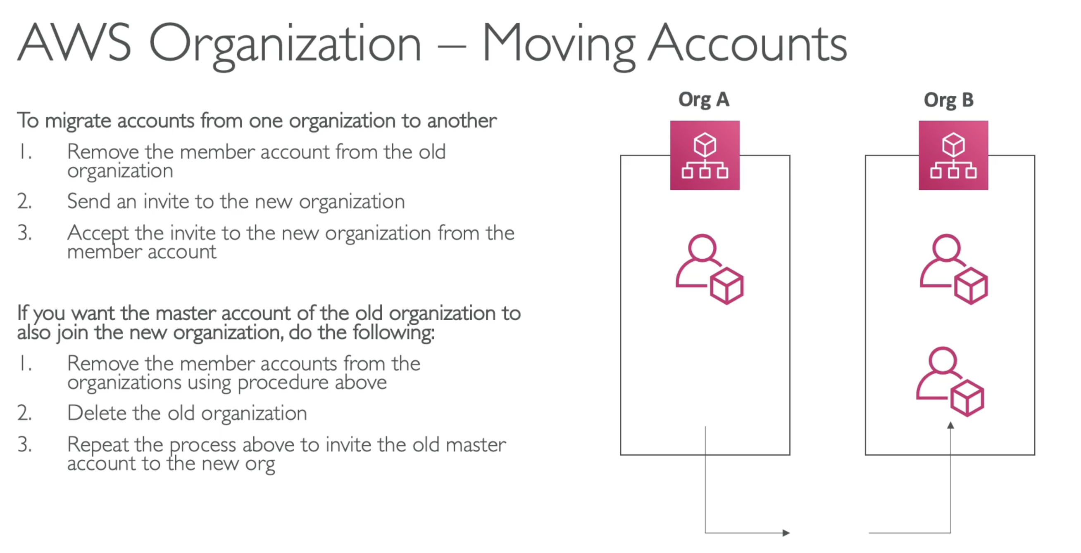

## 243. Organizations – Hands On

## 244. IAM – Advanced

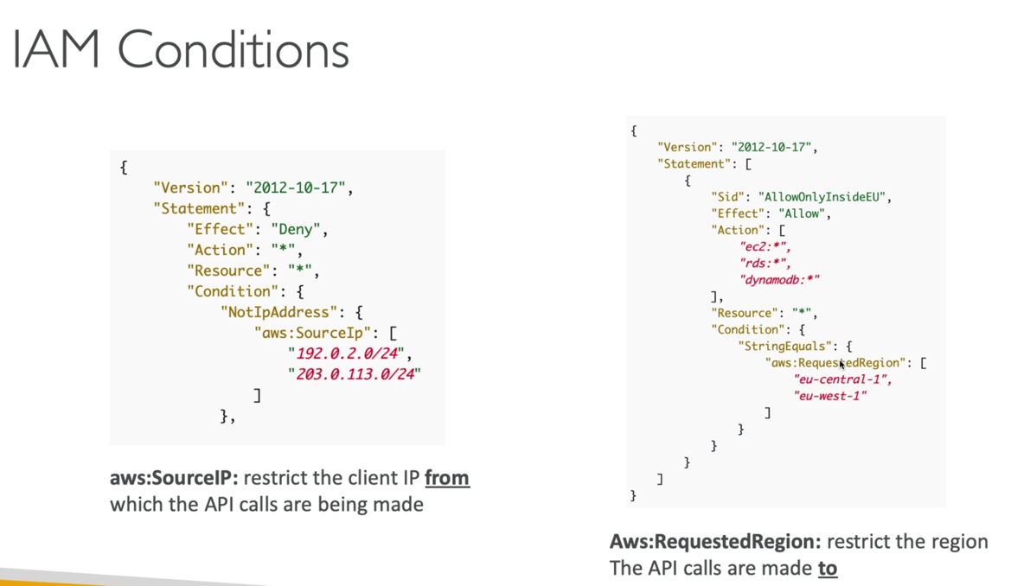

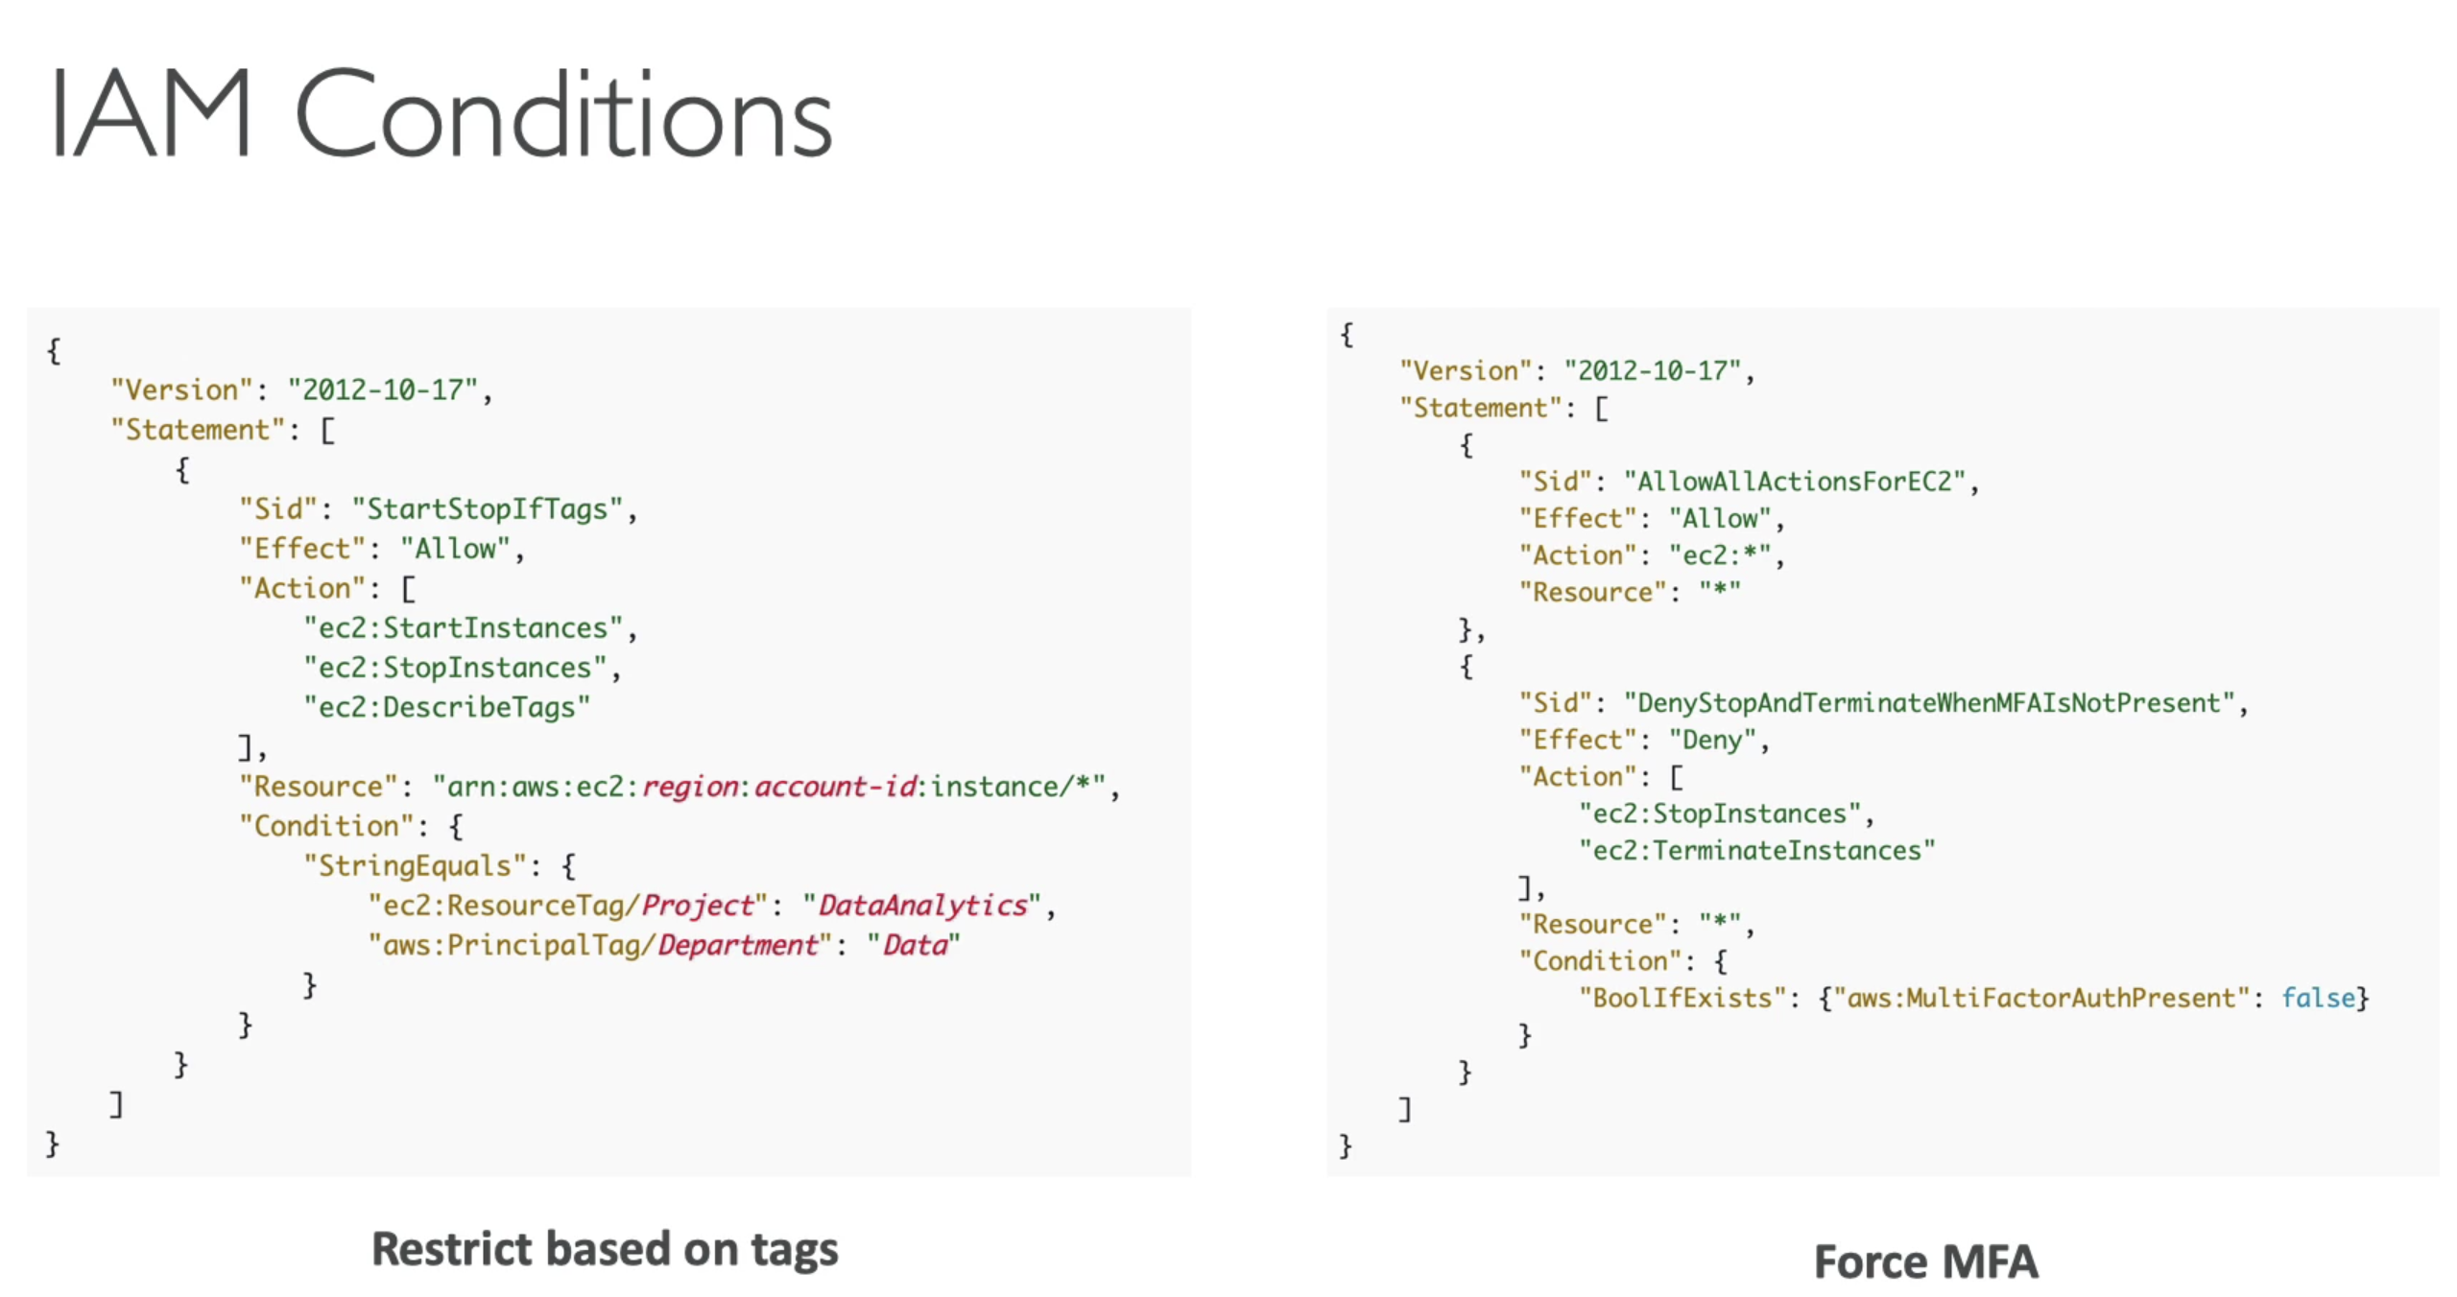

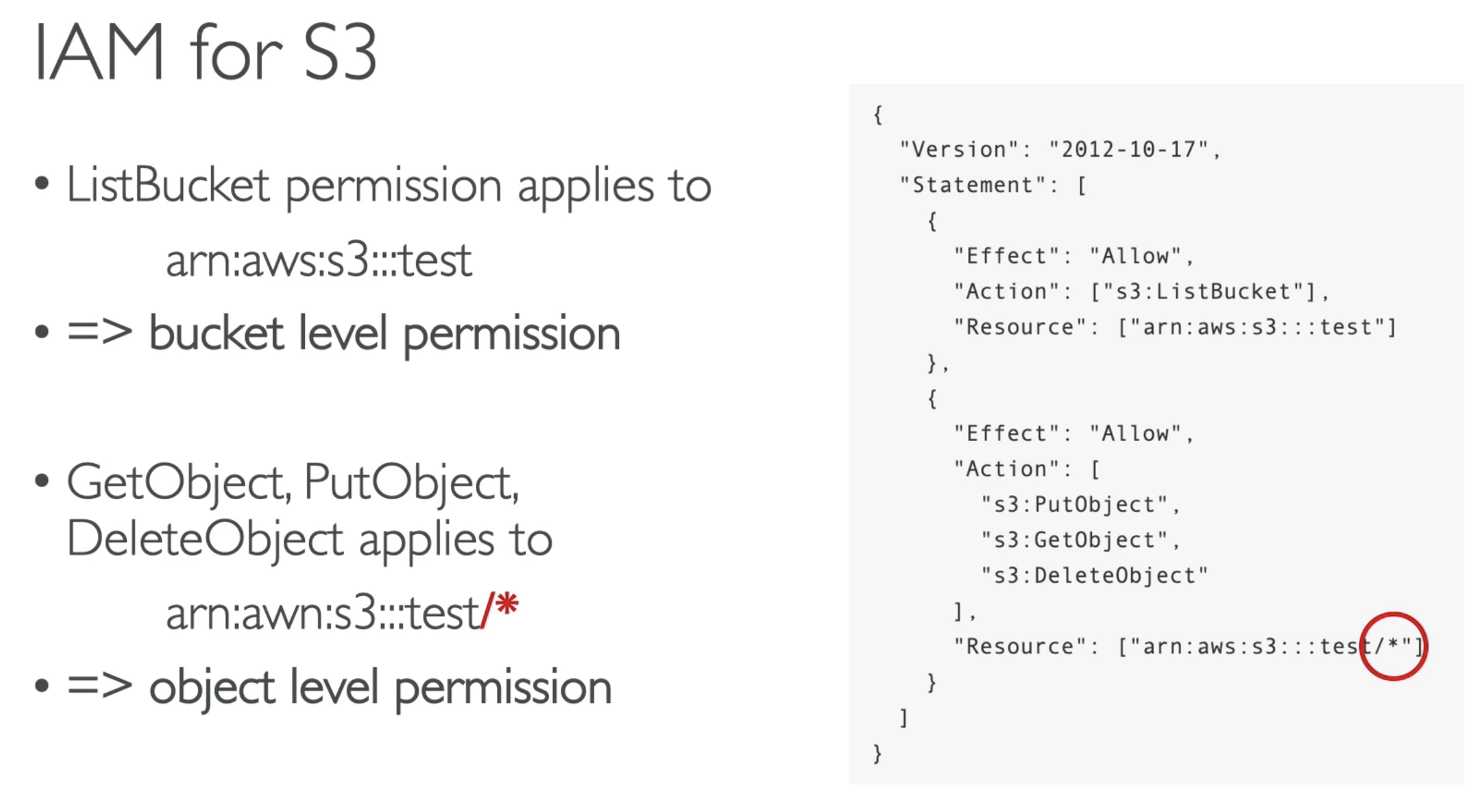

## 245. IAM – Policy Evaluation Logic

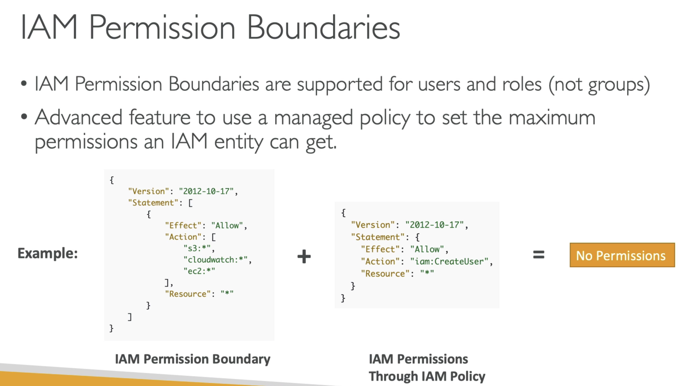

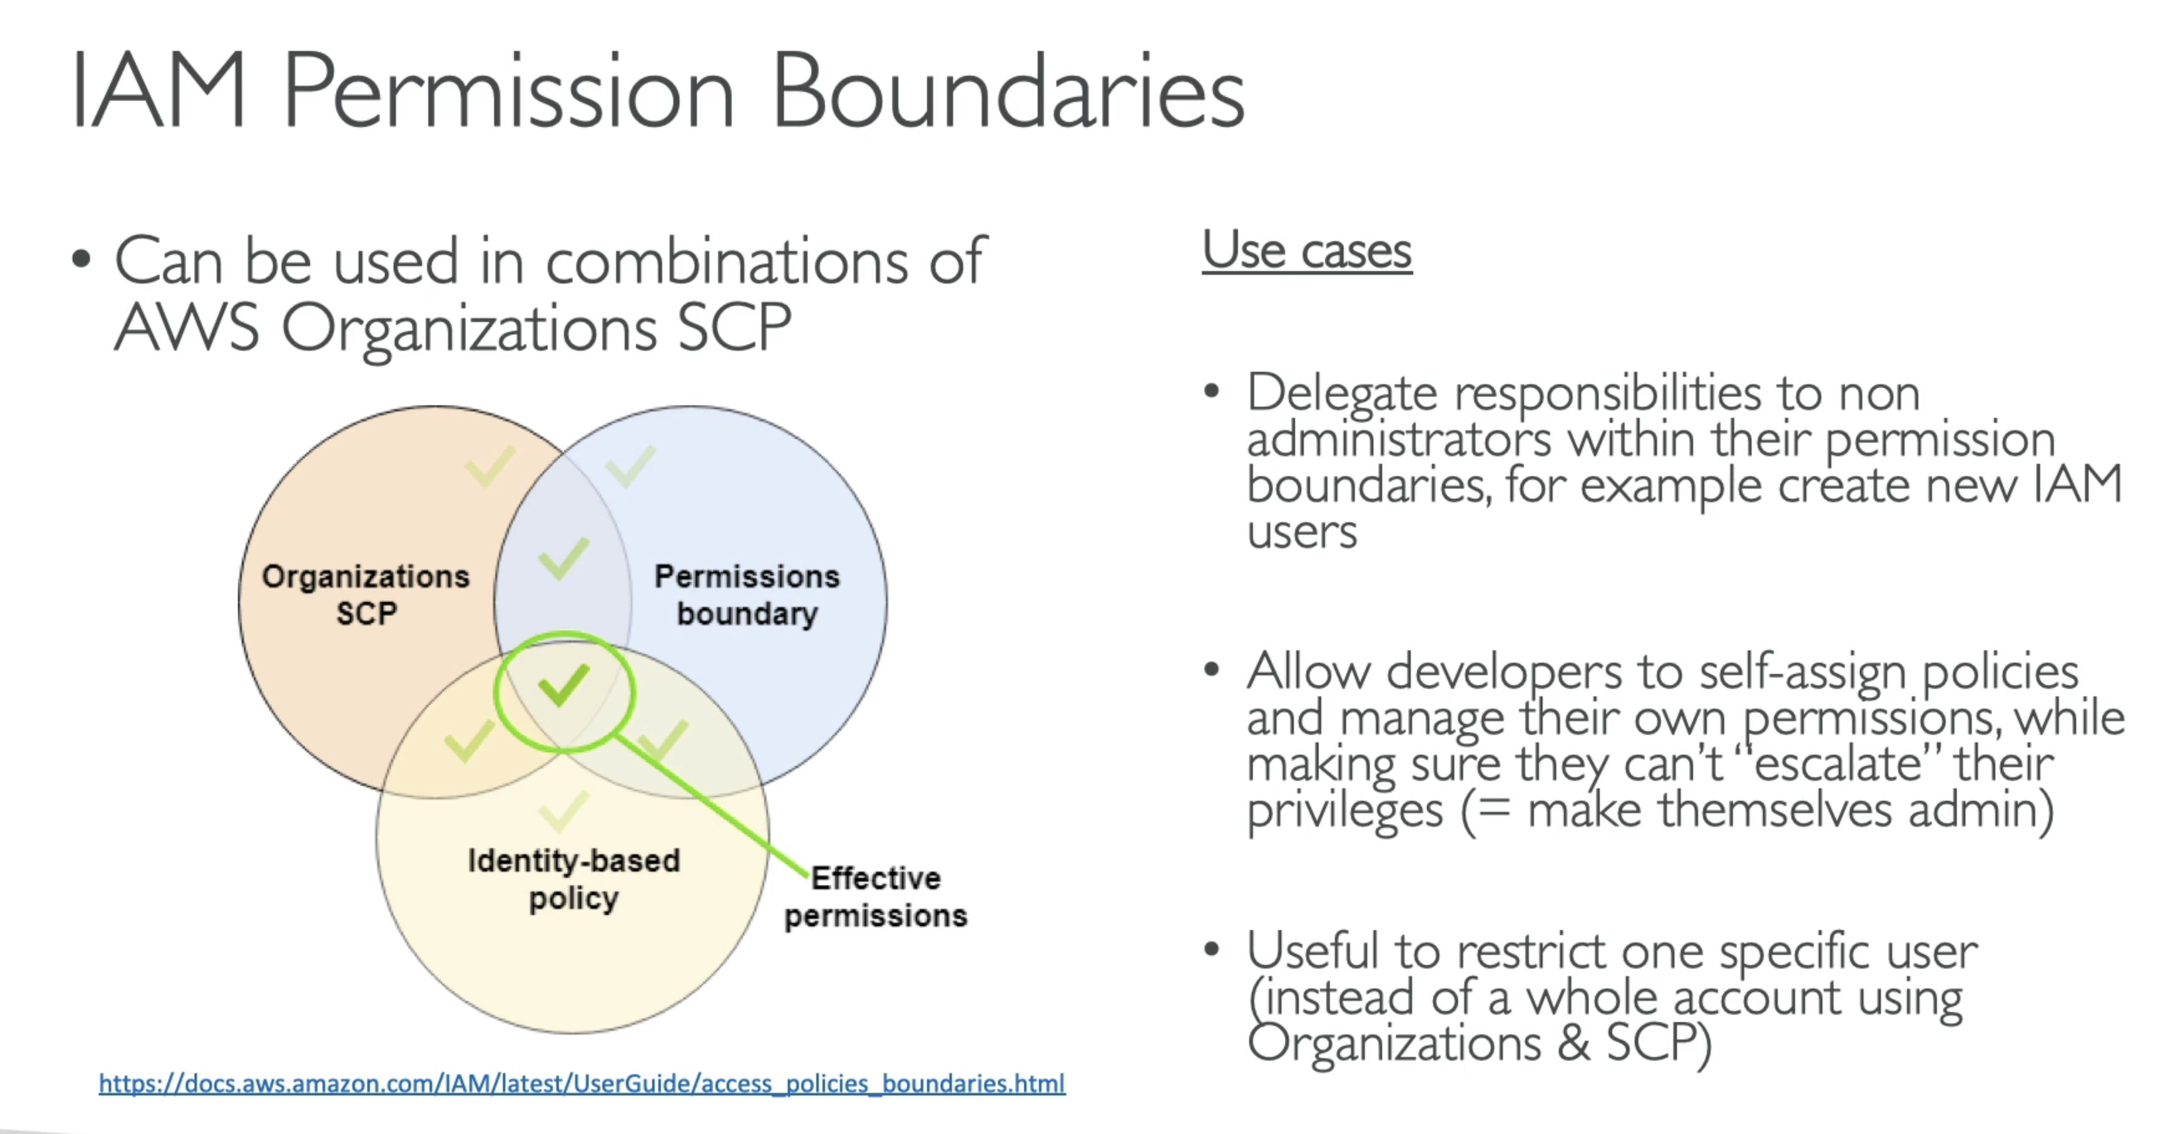

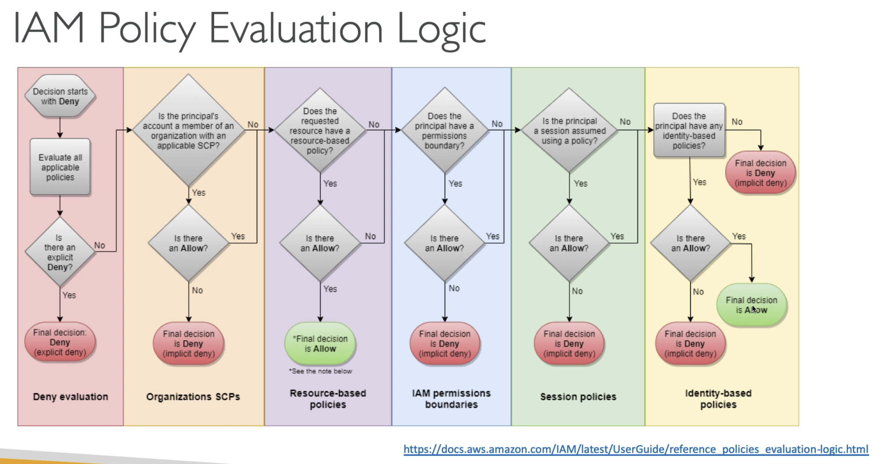

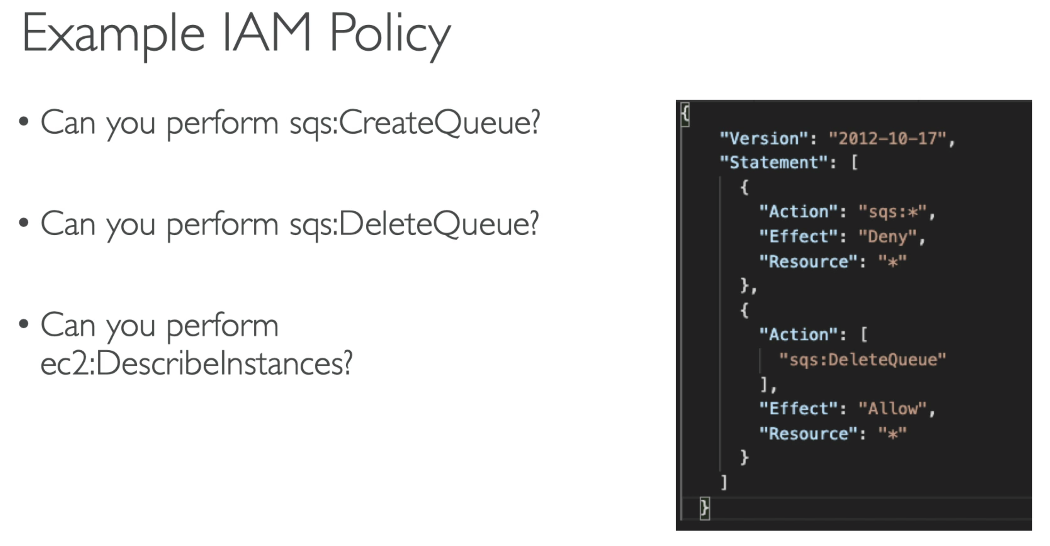

* Since there is a explicit deny on SQS queue, so we cannot create queue or delete queue with this IAM policy
* There is no mention of any ec2 in this IAM policy, neither allow or deny 🡪 so we cannot describe instances with this IAM policy

## 246. Resource Access Manager (RAM)

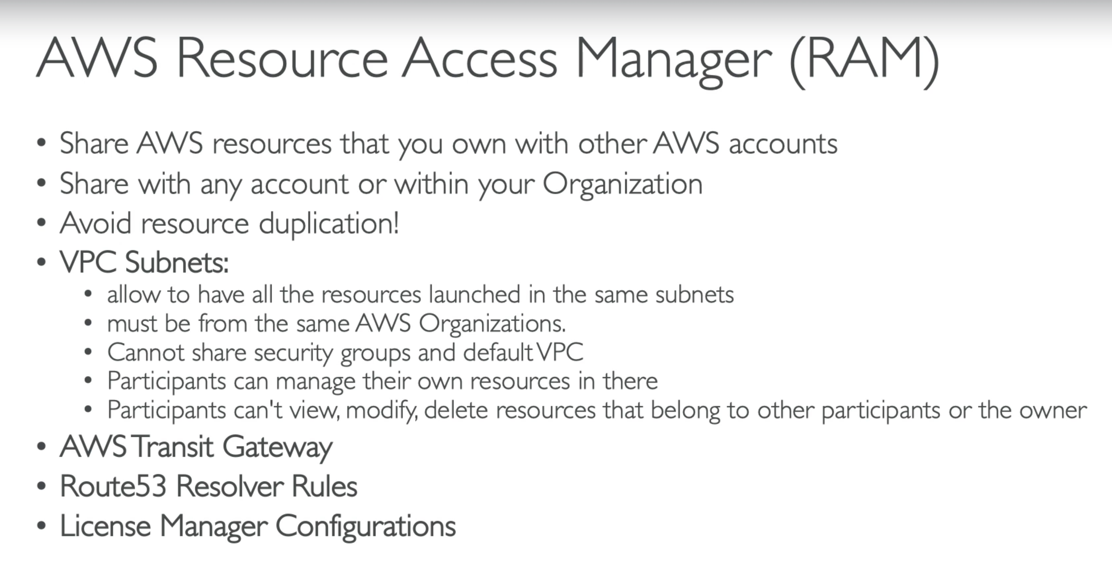

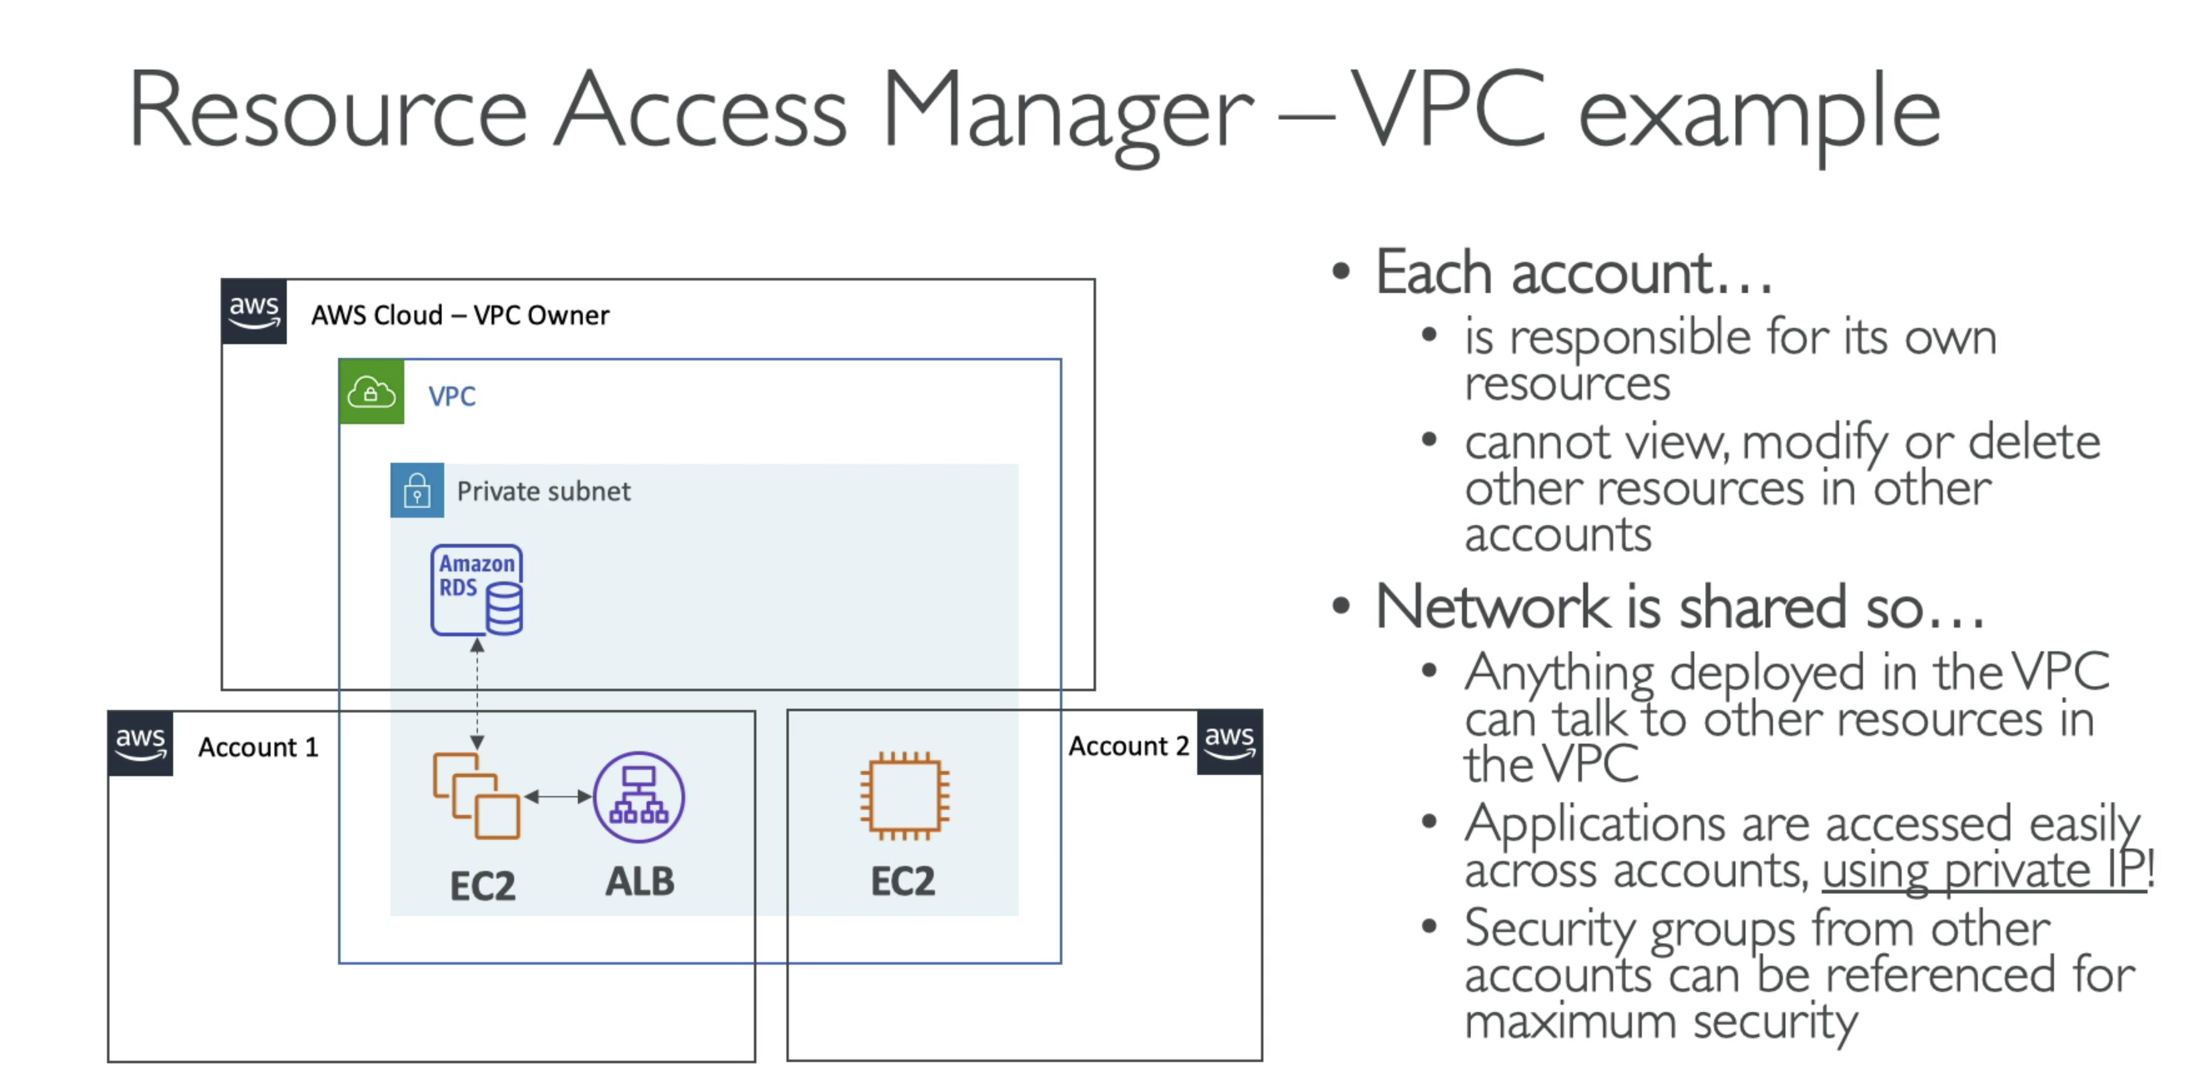

ExamTip:

Use case: Sharing a VPC subnet 🡪 think of RAM

## 247. Single Sign On (SSO) - Overview

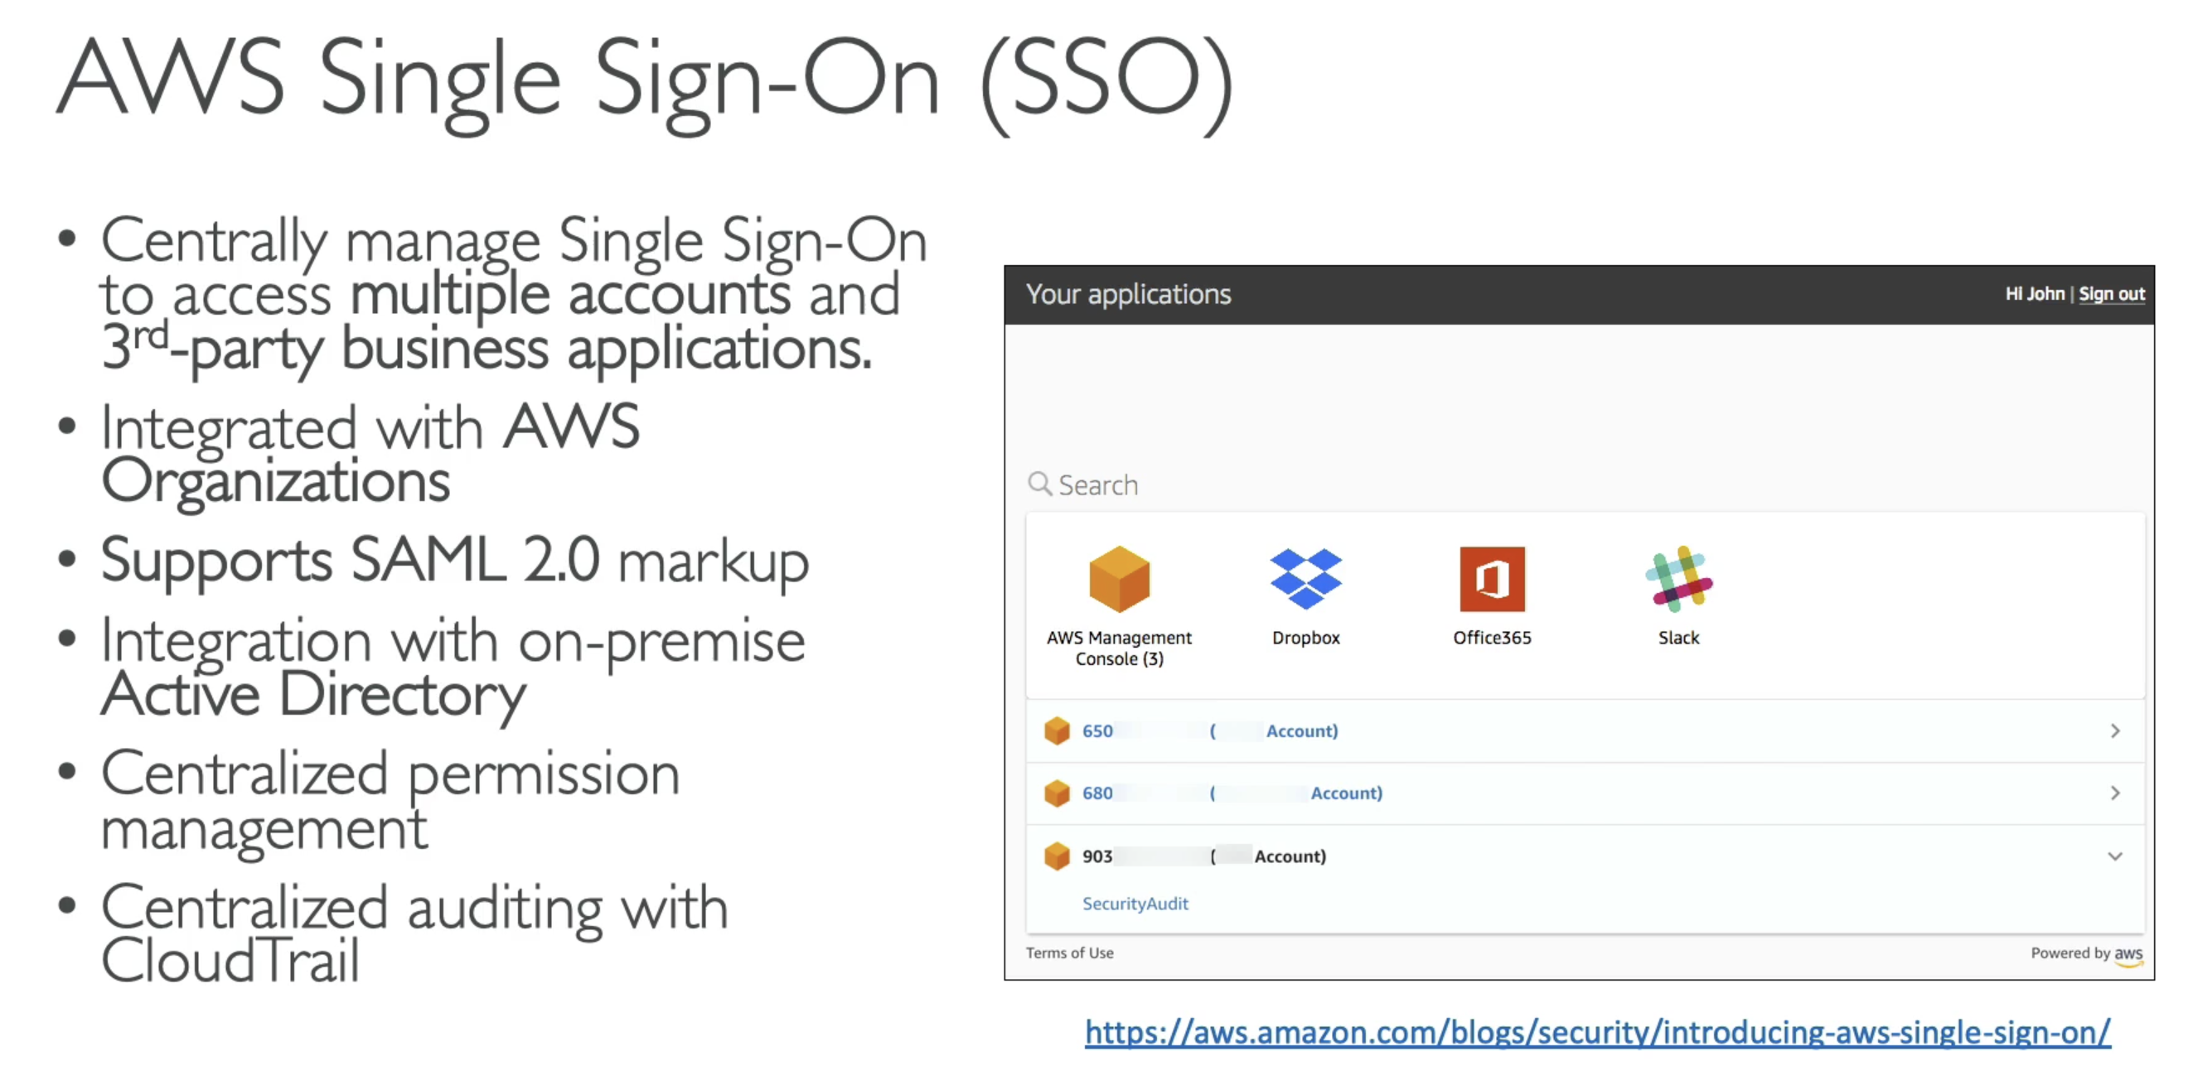

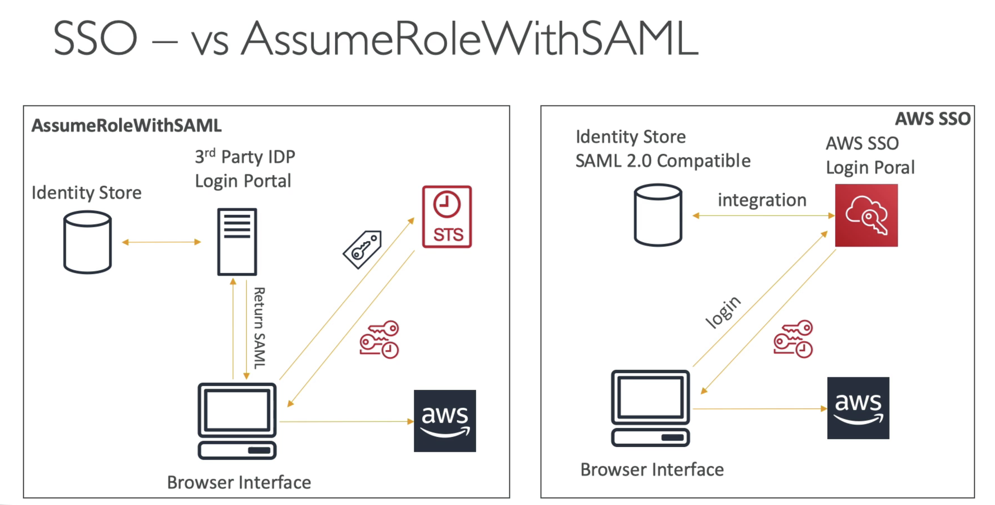

## 248. AWS Single Sign On (SSO) – Hands On